24" FLG X FLG MW EXTENSION

30" FLG X FLG MW EXTENSION

TOP VIEW
ISOMETRIC VIEW

TOP VIEW
ISOMETRIC VIEW

STEEL OR FRP COVER
STEEL OR FRP COVER

1/8" THICK GASKET
1/8" THICK GASKET

Ø24 1/2" O.D.

30 1/2" O.D.
A
A
SHEET TITLE:
FLANGE X FLANGE FRP MANWAY EXTENSIONS

Ø24" I.D.
30" I.D.
DRAWN DATE:
11/17/20
DRAWN BY:
JACK
REV.
00

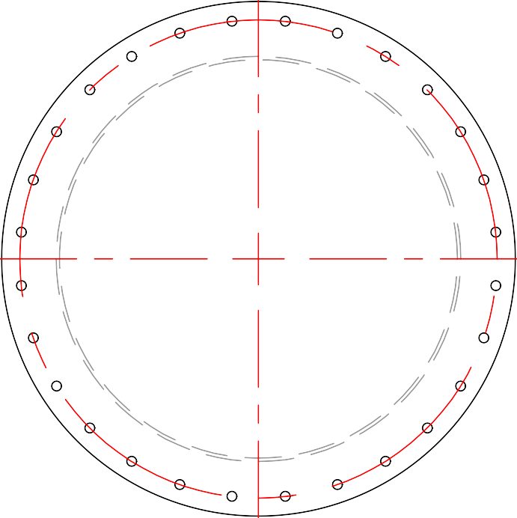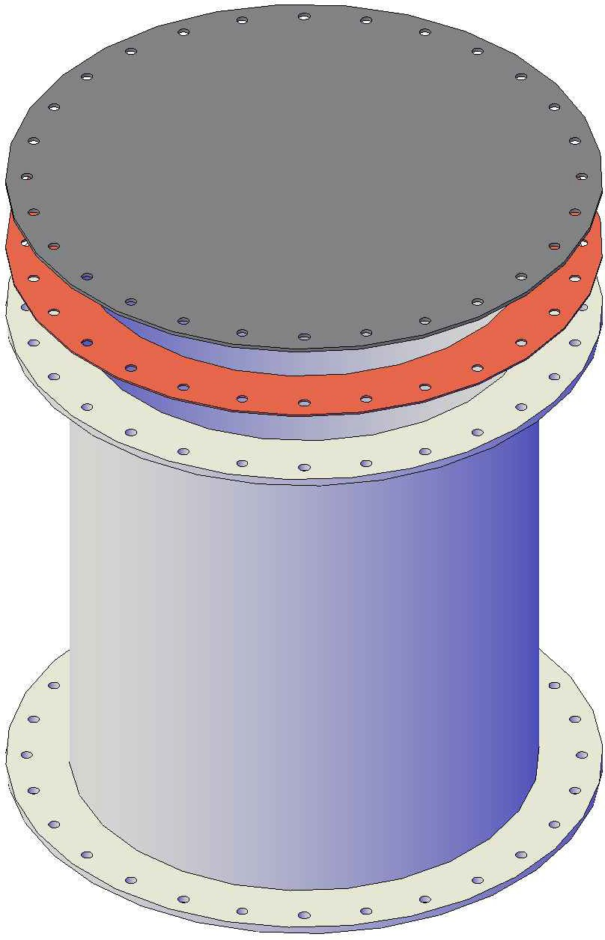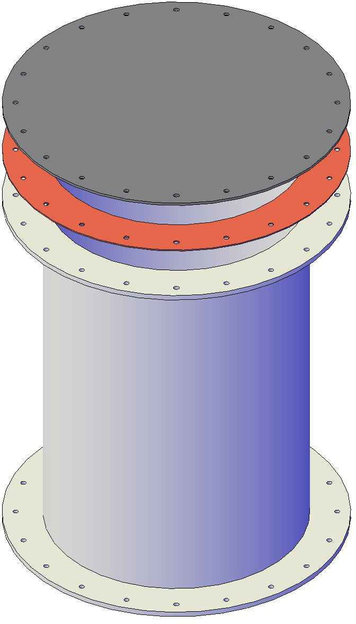

FRONT VIEW

FRONT VIEW

Mailing: P.O. BOX 326, Montreal, MO 65591 MFG: 147 Camdenton Bus. Prk. Dr., Camdenton, MO 65020
P: 573-317-9620

