CONCRETE TOP SLAB
H-20 MANHOLE RING & COVER

FINISH GRADE

BOLT ON LID
10"
1'-6" MIN.
7'-0" [MAX BURY DEPTH]

GRANULAR BACKFILL

RISER PIPE

NATIVE SOIL OR
GRANULAR BACKFILL

ACCESS OPENING

TANK END VIEW

NOTES:
- SEE UNIVERSAL VALVE TECHNICAL DATA SHEET FOR MANHOLE RING AND COVER SIZES AND MODELS.
- THE STORAGE TANK AND RISER PIPES MUST BE ISOLATED FROM TRAFFIC LOADS. IF NECESSARY UTILIZE CONCRETE BACKER ROD, FORMS, OR OTHER BARRIERS TO PREVENT CONCRETE FROM TRANSFERRING LOADS TO THE TANK AND RISER PIPES.
- FIBERGLASS TANK SOLUTIONS (FTS) IS NOT RESPONSIBLE FOR CONCRETE/ ASPHALT TOP SLAB DESIGN OR REBAR LAYOUT.
- FOR Ø12' TANKS A MINIMUM 3'-0" OF GRANULAR BACKFILL IS REQUIRED BENEATH THE CONCRETE TOP SLAB.
- UNDERGROUND STORAGE TANKS ARE DESIGNED FOR A MAXIMUM BURY DEPTH OF 7'-0", CONTACT YOUR SALES REPRESENTATIVE FOR DEEP BURY SOLUTIONS.
- INSURE THERE IS ENOUGH CLEARANCE BETWEEN THE MANHOLE RING AND COVER AND THE RISER PIPE TO ALLOW THE LID TO BE CORRECTLY OPENED/ REMOVED.
- WHEN INSTALLING THE TOP SLAB, ALLOW FOR ADEQUATE DRAINAGE AWAY FROM THE TANK OPENING.
- SEE FTS UNDERGROUND STORAGE TANK INSTALLATION GUIDE FOR RECOMMENDED BACKFILL MATERIAL.

SHEET TITLE:
INSTALLATION DETAIL
PROJECT NAME:

H-20 MANHOLE RING & COVER
DRAWN DATE: DRAWN BY: REV.
07/11/21 JACK 00

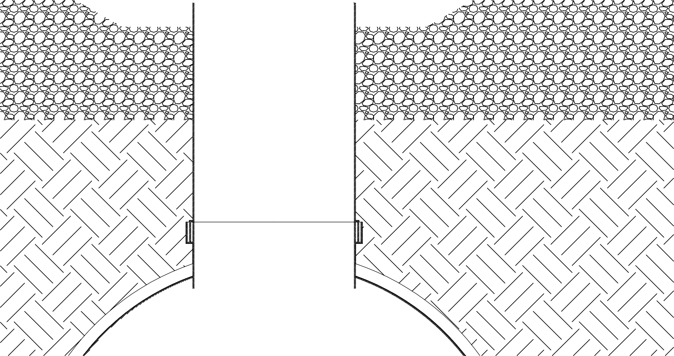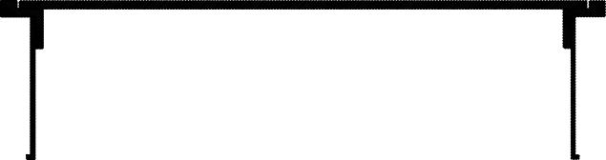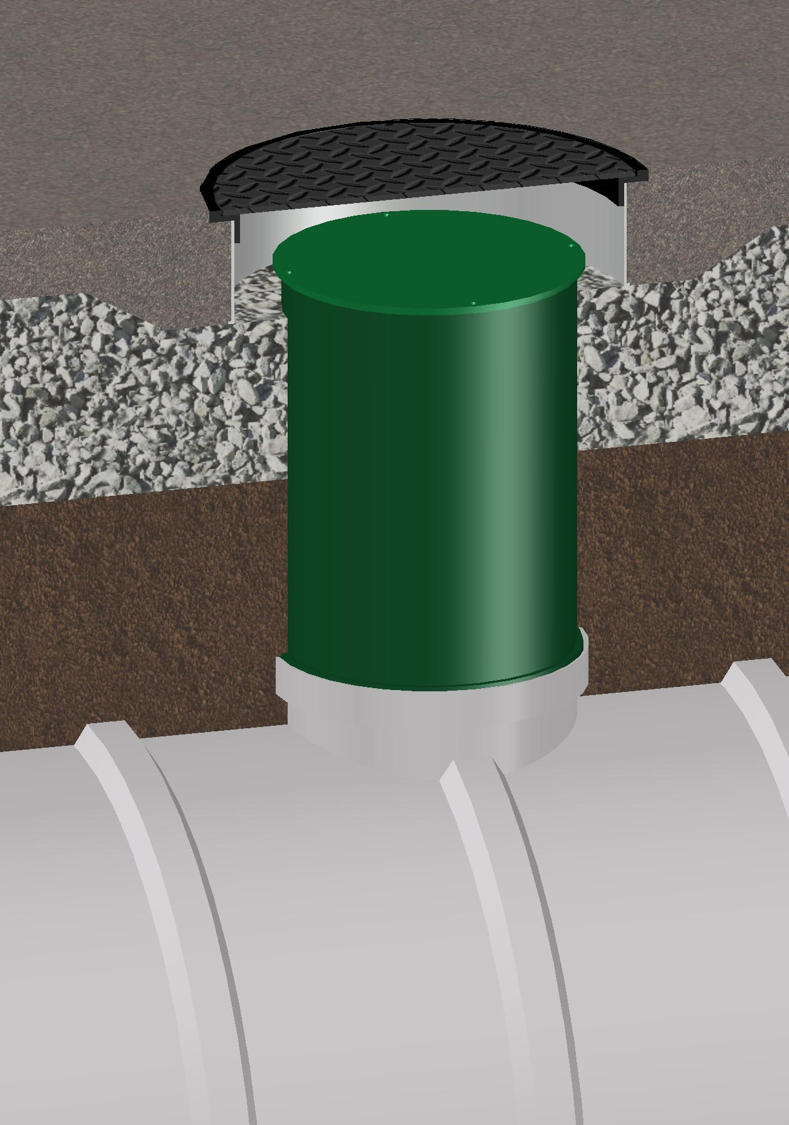
6" MIN.

Mailing: P.O. BOX 326, Montreal, MO 65591 MFG: 147 Opportunity Rd.,
Camdenton, MO 65020
P: 573-317-9620

