

FRP field installed Inlet Hub
Overview.
Site safety is paramount for a successful installation of an FRP hub to an existing wet well. Please observe all applicable state and local regulations concerning shoring of excavations, proper ingress and egress of open cut conditions, and all personnel PPE while performing this task.
It is also critical to be aware of the weather and temperature conditions at the time of installing the FRP field hub. Area shall be kept dry, and free of loose and falling debris. In extreme cold or heat, allow for longer or shorter working times for the adhesives supplied. Moisture must be avoided for good structural bonding of the FRP hub to the wet well.

- Locate inlet INVERT elevation on side of tank. From this mark, draw out the full diameter of the inlet pipe od, adding a ½” for clearance.
- Using a 4” grinder equipped with a 4.5” continuous rim diamond cutting wheel, cut to the inside of the line the full depth and circumference of the pipe penetration.
- Dry fit the inlet pipe, allow for 3”-6” inside the wet well.
- Install the Press Seal gasket in the FRP hub, and slide over the inlet pipe, gasket facing away from the wet well.
- Slide the hub assembly up against the wet well wall.
- Using the gasket to center the hub, trace the square outline of the FRP hub saddle on the wet well. Any rib supports that are inside of this line, may need to be removed. The surface of these must be sanded flush with the flat portion of the tank wall.
- (Note: the rib supports are secondarily applied to the wet well structure. They may be flush cut along the top and bottom the width of the hub, and square cut at each end. This will not hurt the overall tank structure to do this)
- Using 40-60 grit flap wheels in the 4” grinder, fully sand around the entire marked area where hub will be seated to the side of the tank, extending past the marks by a minimum of 1” past on all sides. If support ribs had to be removed, these must be sanded until flush as possible with the flats of the wet well.
- Once completely sanded, wipe away dust and wet well side of hub clean with Acetone solvent and clean rag.
- Using the supplied hardware kit, drill a 3/16” hole in one corner of FRP hub thru to the wet well. Secure with supplied tapcon and washer. Square up the hub and pilot hole, secure the other 8 locations. This completes the dry fit stages of installation. Remove and set aside all hardware near work area, and slide FRP hub back up the pipe to allow access to the rough side.
- Using the supplied adhesive kit, apply 2 circumferential beads of adhesive ¼”-3/8” wide to the FRP hub. Apply 1 additional bead around the inlet pipe penetration on the tank wall. (This may take several tubes of adhesive, depending on the size of inlet hub required)
- Bed the FRP hub up to the tank wall, and using the pilot holes and fasteners, secure the hub to the tank. NOTE: if temperature is hot (above 70 degrees F) work quickly once the application of adhesives has begun, as open working time will shorten significantly. If below 55 degrees f, allow a full day to cure, or use a supplemental heat source to raise the ambient temp around the hub assembly)
- With the remaining adhesive supplied, apply a final bead along the outer edge of the FRP hub, along with a small amount over each fastener.
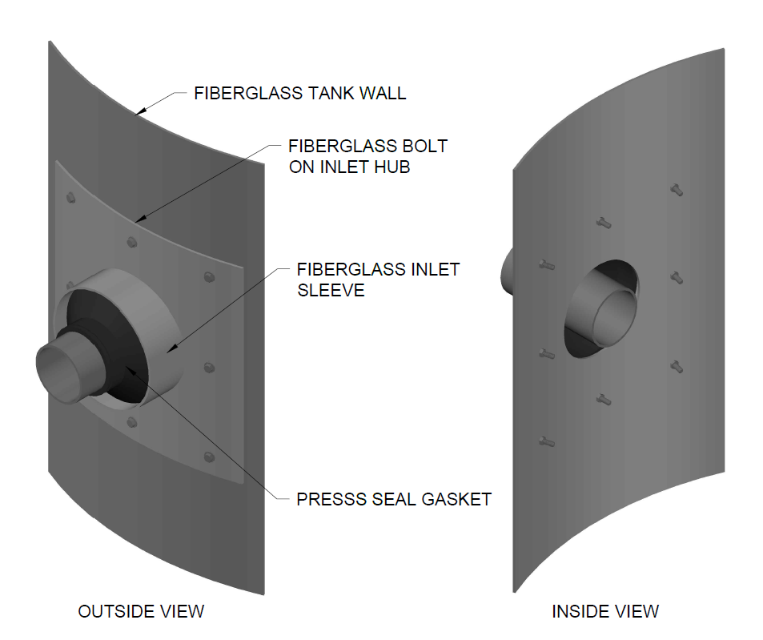
- Using the supplied constriction bands, wrap and tighten the press seal hub to the inlet pipe.

